----Stock Market Analytic

In the Stock market analytic, we are interested in predicting the fluctuations in closing prices of the stock. Since we cannot subtract one date from another directly in Hive, we are using a pseudo column called rank which ranks the rows based on Stock name and date. Below is the query:

CREATE TABLE closing_prices as

select ticker_symbol , date_ , close , rank() over (partition by ticker_symbol order by date_) as rank

from stock_history ;

For Convenience, the results of the query are stored in a table call closing_prices.

Below is the partial screen shot

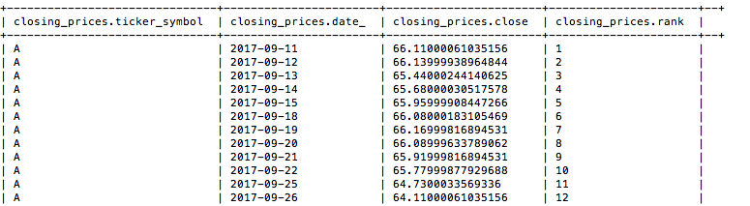

To identify the percentage, change in the closing prices compared to previous days the below query can be used.

Select x.ticker_symbol , x.date_ , pct_change*100 pct_change from (

select a.ticker_symbol , a.date_ , (a.close - b.close)/b.close pct_change

from

closing_prices a , closing_prices b

where a.ticker_symbol = b.ticker_symbol

and a.rank - 1 = b.rank) x;

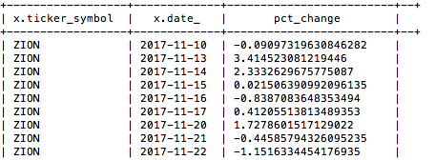

The sentiment achieved from the sentiment analysis and the stock market analytic can be combined using the below query.

SELECT x.company ,x.ticker_symbol, x.date_ , x.total_sentiment, y.pct_change*100 pct_change

FROM sentiment x,

(select a.ticker_symbol , a.date_ , (a.close - b.close)/b.close pct_change

from

closing_prices a , closing_prices b

where a.ticker_symbol = b.ticker_symbol

and a.rank - 1 =b.rank) y

where x.ticker_symbol = y.ticker_symbol

and x.date_ = y.date_;

Below is the screen shot of the partial output

